# CS 255 System Design Document Template

This template lays out all the different sections that you need to complete for Project Two. Each section has guidance to prompt your thinking. You will need to continually reference the interview transcript as you work to make sure that you are addressing your client’s needs. There is no required length for the final document. Instead the goal is to complete each section based on what your client’s needs are. Remove this note when you are finished, and replace all bracketed text with the relevant information.

## UML Diagrams

### UML Use Case Diagram

### UML Activity Diagrams

**Use Case - 1**

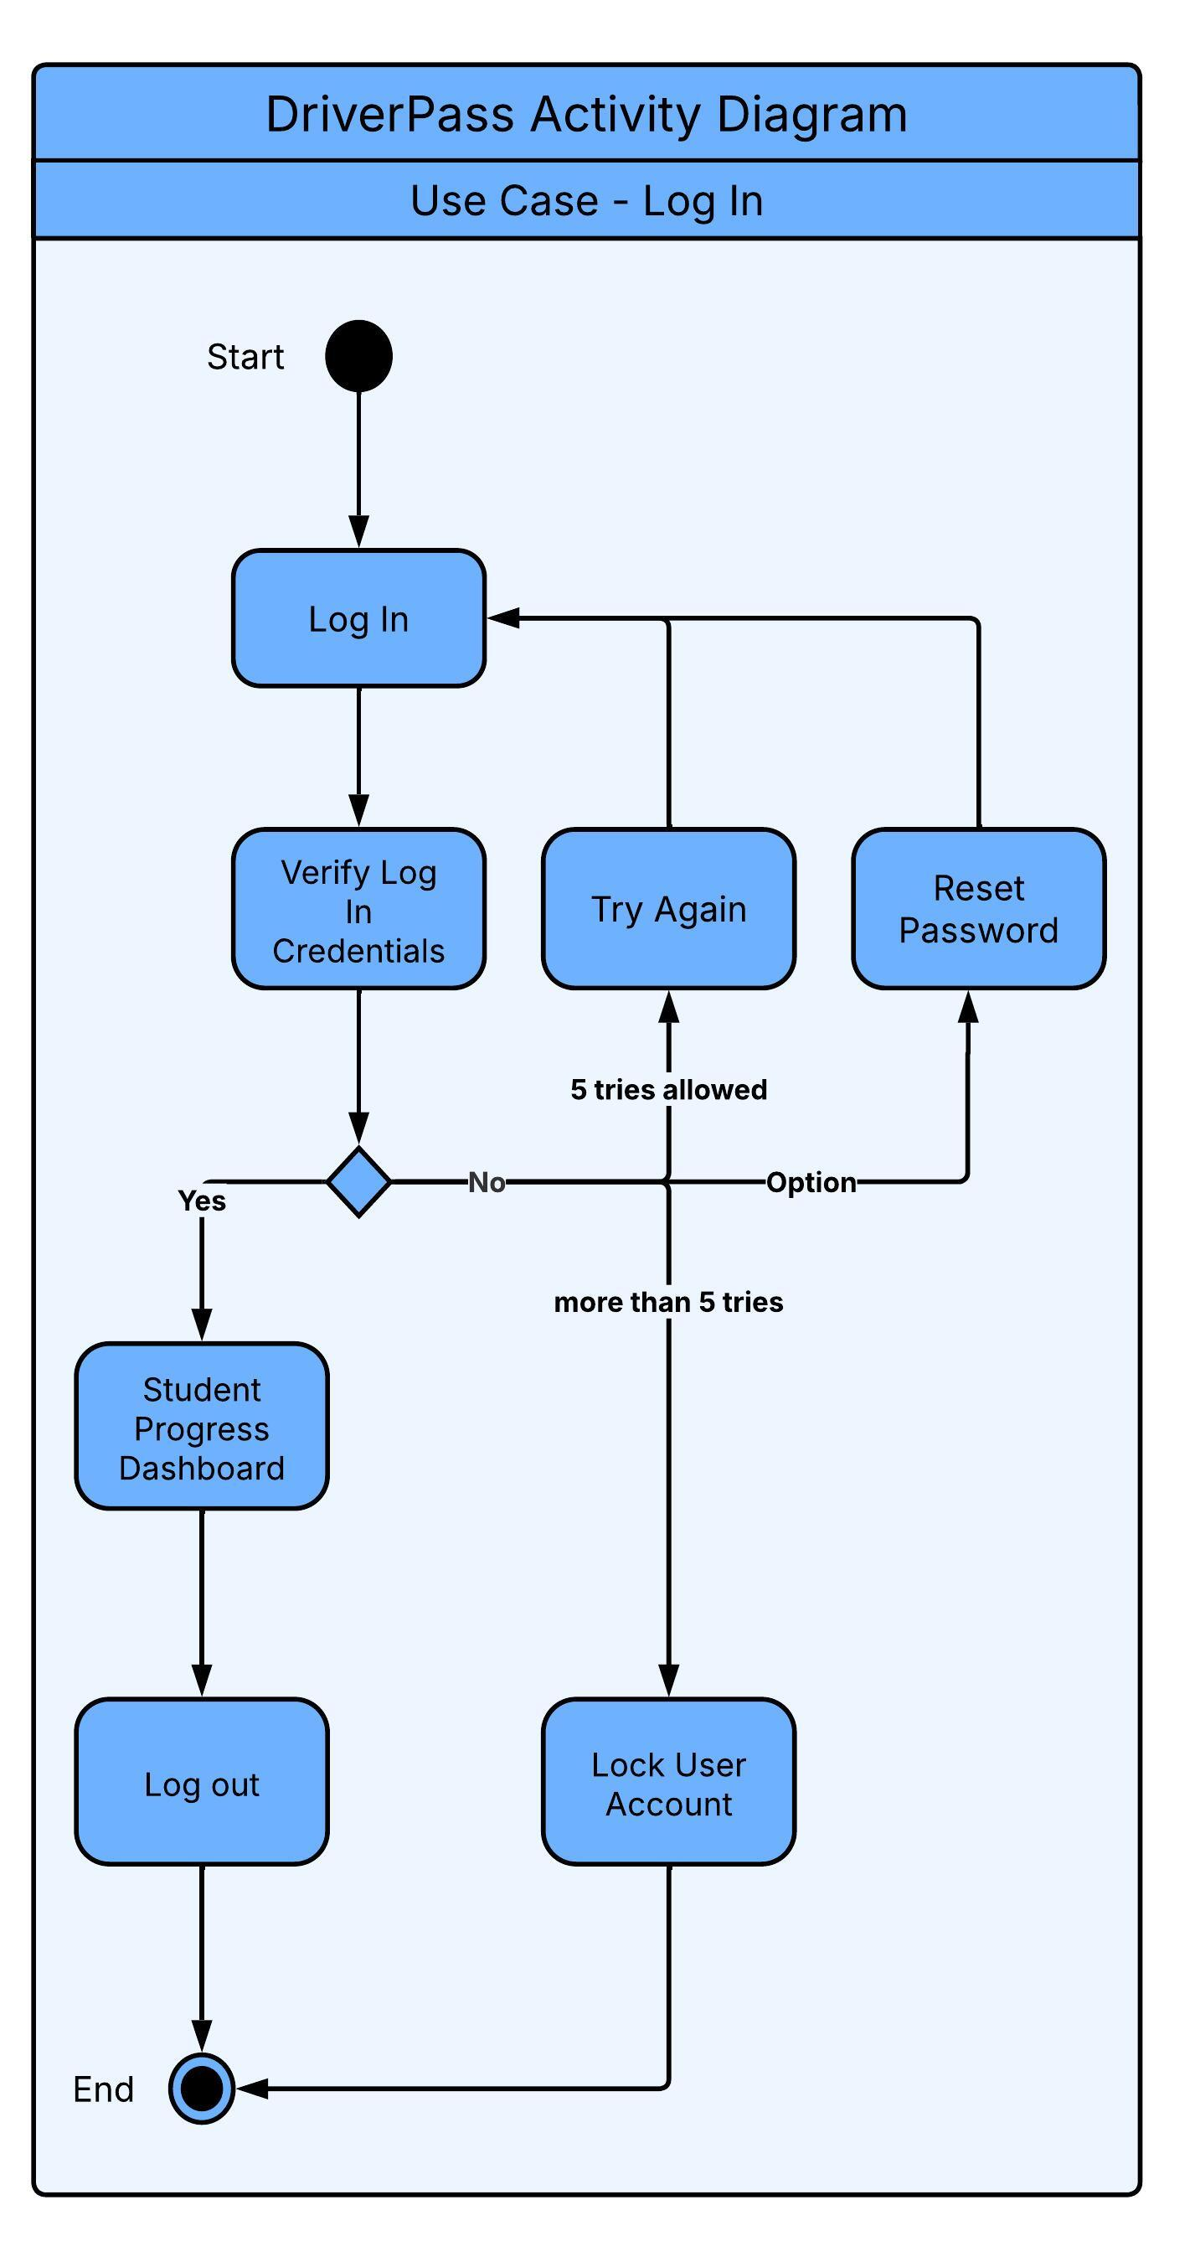

**Use Case – 2**

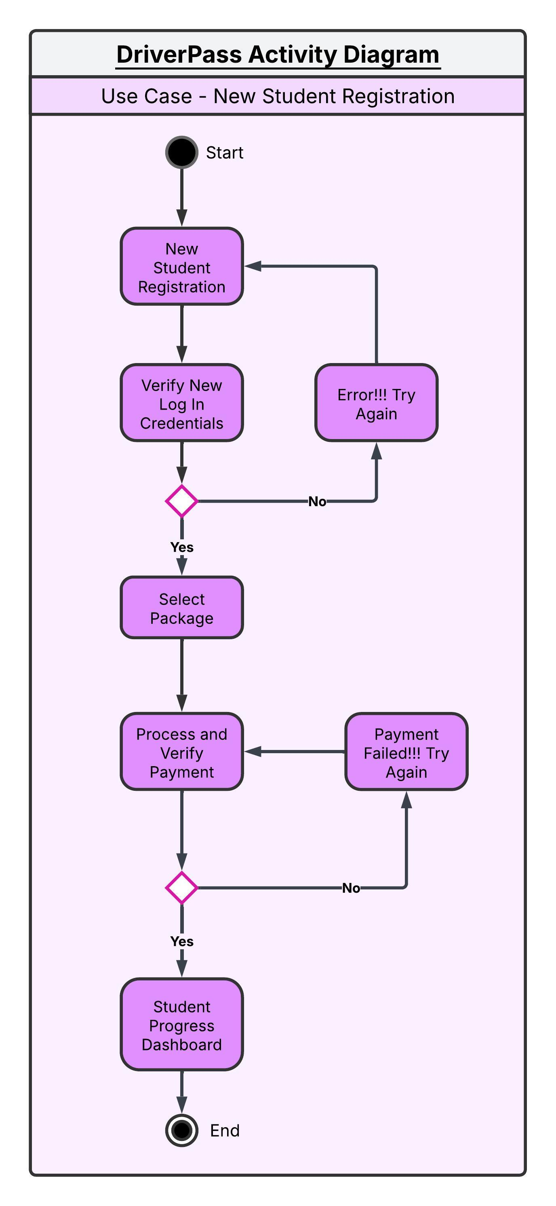

### UML Sequence Diagram

### UML Class Diagram

## Technical Requirements

*[Based on the diagrams you have created, describe the technical requirements of your system. These requirements should address the required hardware, software, tools, and infrastructure necessary for your system design.]*

* The system should be able to perform in most of the web-based environments, with a loading time of 3 seconds, and should be updated every month as needed with only 3 hours’ downtime per update.
* The system should be able to run on most platforms such as windows, macOS, Unix, Linux, etc., most browsers such as MS edge, chrome, Firefox, safari, etc.,
* The system should adjust its UI automatically to run on mobile browsers and the backend should use the required database to store and manage data efficiently. Tools such as MySQL, PostgreSQL, MongoDB, etc. can be used to fulfill these requirements.
* After logging into the system, the student interface shall show their profile, link to access their course materials, progress, upcoming appointments and exams, options to modify their driving lessons, and instructors’ feedback.
* The employee and Admin interface shall show the list of all the students with their upcoming exam or driving lesson. The employee should be able to click the name of each student to go through their detailed activity, progress, and ability to modify their reservations and account itself.
* The system should be efficient to update, repair, Improve and enhance with minimal risks which could be achieved by well-organized codes, clear and concise documentation, and error monitoring.
* The system should be scalable to handle increasing workloads, data volumes, and traffic to accommodate growth and change overtime while maintaining its performance and stability.
* The system should update the real-time booking inventory when students reserve, cancel and reschedule their driving lessons and notify the driver instructor.
* The system shall track the activities of students when they make changes to the reservation and when they make progress in online classes in practice and update it in their profile dashboard.
* The server, memory management, and store management should be handled through the cloud service providers which will be online 24/7.